Unit 5:
Mineral resources

Resource:
- Typically, resources are materials or other assets that are transformed to produce benefit and, in the process, may be consumed or made unavailable.
- From a human perspective a natural resource is anything obtained from the environment to satisfy human needs and wants.
- Anything economically useful or used to extract economic benefits is called a resource.
Types of resources
1. Renewable resources: these are natural resources which can be replaced by natural processes and forces persistent in the natural environment.
A - Continuous renewable resources: continuous renewable resources such as the movement of water (hydropower, tidal power and wave power), wind and radiant energy from geothermal heat (used for geothermal power) and solar energy (used for solar power) are practically infinite and cannot be depleted. These resources will last forever and their availability of production is independent of their consumption or usage.
B – Sustainable renewable resources: these renewable resources can be sustained in the natural environment by maintaining a balance between their production and consumption. Uncontrolled use and wastage of these resources may led to resource extinction such as natural vegetation, fish, soil, fresh water, plant and animal species etc.
2. Non-renewable resources: these are natural resources which take thousands of years to naturally and cannot be replaced as fast as they are being consumed. These cannot be reused and their quantities are fixed in environment.
A – Power resources: those non-renewable resources which have the potential to produce energy are called non-renewable power resources for example fossil fuels including coal, mineral oil and natural gas and uranium
B – Mineral resources: a mineral is a naturally occurring non-renewable solid chemical substance formed through bio-geo-chemical processes having characteristic chemical composition, highly ordered atomic structure and specific physical and chemical properties.
Mineral formation processes:
1. Igneous process: by the solidification of magma beneath the surface of the earth, intrusive igneous minerals are formed. Magma cools down slowly inside the crust thus we see the minerals of course to intermediate grain size. Examples granite and gabbro by the solidification of lava on the surface of the earth, extrusive igneous minerals are formed. Lava tends to cool quickly, therefore have smaller crystals as fast cooling does not allow large crystals to grow. Examples basalt and rhyolite.
2. Sedimentary process: sedimentary minerals are formed by the deposition of mineral at the earth’s surface and within bodies of water. The process starts with weathering and erosion in a source area, and then sediments are transported to the place of deposition by water, wind, mass movement or glaciers examples limestone and sandstone.
3. Metamorphic process: form when pre-existing rocks (ignites, sedimentary PR metamorphic) are exposed to high temperatures and pressures under the earth’s surface, pre-existing minerals are instable at the higher temperature and pressure conditions therefore: transform into new minerals while others recrystallize and grow larger.
Types of minerals:
1. Metallic minerals
2. Non-metallic minerals
Difference between metallic and non-metallic minerals:
Metallic minerals
- Metallic minerals are those minerals which can be melted to obtain new products.
- Iron, copper, bauxite, tin, manganese are some examples.
- These are generally associated with igneous rocks.
- They are usually hard and have shine or luster of their own.
- They are ductile and malleable.
- When hit, they do not get broken.
- These are good conductors of heat and electricity
- They have high specific gravity
- They have higher melting point
Non – metallic minerals
- Non-metallic minerals are those which do not yield new products on melting.
- Coal, salt, clay, marble are some examples.
- These are generally associated with sedimentary rocks.
- They are not so hard and have no shine or luster of their own.
- They are not ductile and malleable.
- When hit, they may get broken into pieces.
- These are poor conductors of heat and electricity
- They have low specific gravity
- They have low melting point
Mining methods:
- Open cast mining:
When the steam/layer/deposit is exposed to the earth’s surface, it is extracted through open cast mining method.
Generally, very few economically important minerals are exposed on the surface, thus this method is practiced on very limited level.
Advantages:
- Very easy to perform.
- Cheaper to extract.
- Doesn’t require highly technical skills.
- Comparatively safer than other methods.
- No need to dig vertical shaft or horizontal tunnel.
- Large scale of production.
Disadvantages:
- Very few minerals are exposed on the surface, thus is performed on a very limited level (limestone extraction in pakistan)
- Machinery and equipment required excavators, shovels, hammers and trucks for transportation, which makes it very expensive.
- Pollutes natural environment.
- Depressions are formed on land.
- Dumping of waste materials into the surface water bodies pollutes hydrosphere.
- Deforestation of natural vegetation.
- Dust and smoke generated on mining site creates air pollution.
- Exposure of mine workers to constantly high noise levels.
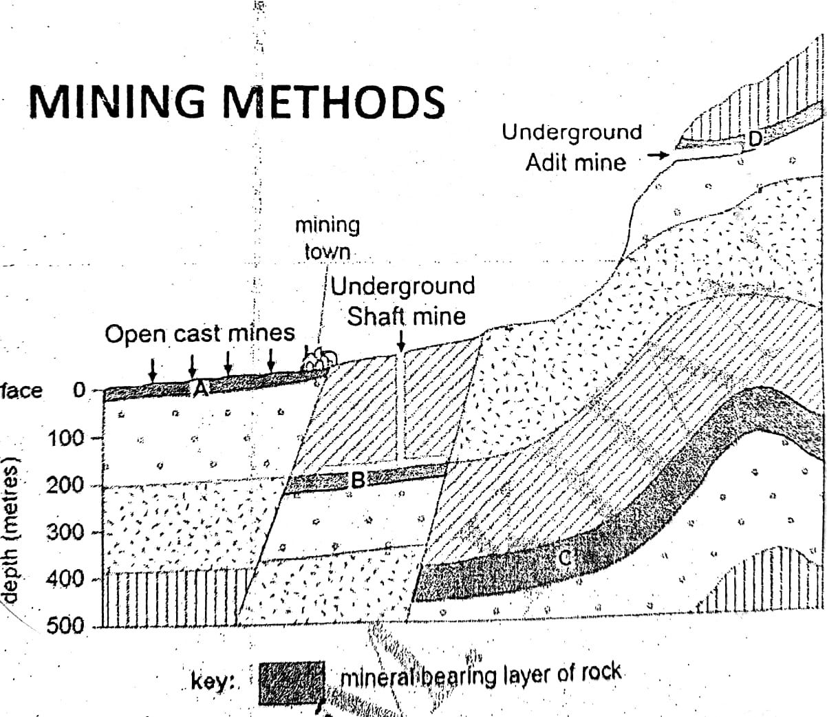
2. Underground mining:
A. Shaft mining method
B. Adit mining method.
A. Shaft mining:
Most minerals are found beneath the earth’s surface; thus, they are extracted through shaft mining by digging a vertical shaft into the ground and when mineral seam is reached the process of extracting starts by making horizontal tunnels.
Machinery and equipment required:
Large drilling machines, excavators, transportation trolleys, lifts, heavy power generators, transportation equipment like trucks.
Advantages:
- Most economically important minerals are found beneath the earth’s surface and thus can only be extracted through shaft mining method.
- Large quantity of minerals can be extracted through this method.
Disadvantages:
- Difficult to perform.
- Very expensive to dig shaft and arranging for transportation of minerals both beneath the surface and bringing them onto the surface.
- Large labour force is required (skilled labour to operate mining machinery and unskilled labour mostly for transportation of minerals).
- Require high degree of skills for making underground tunnels, digging vertical shaft and to operate sophisticated mining machinery.
- Requires heavy machinery both for digging and tunnels for transportation of minerals.
- Very dangerous to perform
- Mine workers may be exposed to harmful toxic gases.
- Roofs of underground tunnels may collapse.
- Problem of ventilation for mine workers.
- Underground mines may get flooded either by the leakage of canal water within the tunnel or by the flash floods on the surface.
B. Adit mining:
When mineral seam is exposed on the hill slope. It is extracted throughout adit mining method in which a tunnel is dug around the mineral seam beneath the surface from the mountain slope.
Advantages:
- Large quantities of minerals can be extracted.
- No additional cost involving minerals exploration surveys.
Disadvantages:
- Very few minerals are exposed on hillside, thus it is practiced on a limited scale.
- All other disadvantages of shaft mining.
Machinery and equipment required:
Large drilling machines, excavators, transportation trolleys, lifts, heavy power generators, transportation equipment like trucks.
In case of adit mining, selection of mining method that is mechanized mining or manual extraction depends mainly on the;
- Thickness of mineral seam encourages use of machinery thin seam encourages use of manual labour
- Inclination of mineral seam horizontal seam encourages use of machinery steep seam encourages use of manual labour

Cement manufacturing: cement manufacturing is carried out as a system of inputs, processes and outputs.
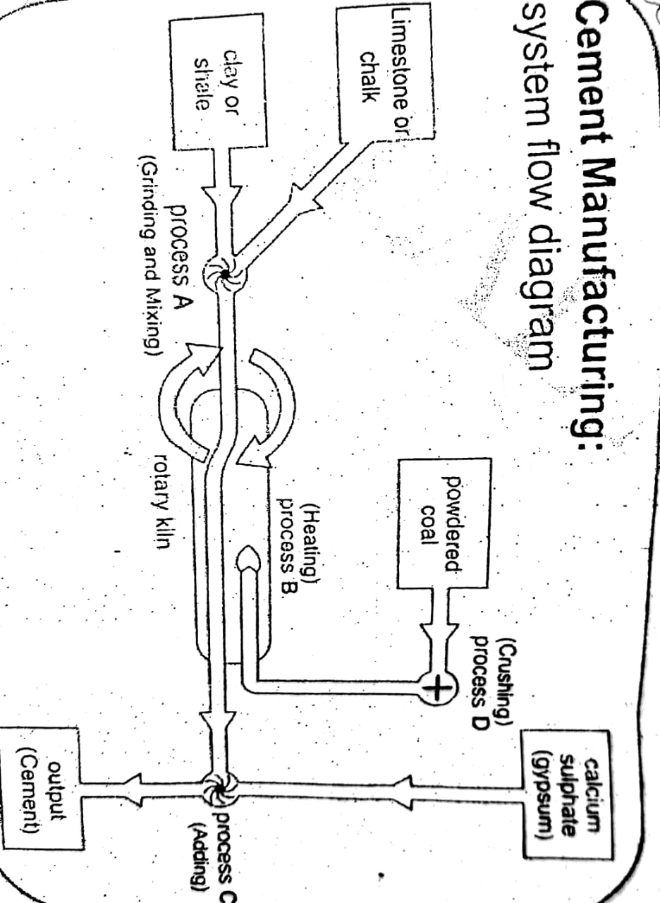
Inputs:
A. Natural inputs:
Raw materials: to manufacture cement
- Limestone or chalk
- Clay or shale
- Gypsum / calcium sulphate

Power sources: to power the rotary kiln for heating the mixture of raw materials
- Coal
- Mineral oil
- Natural gas
- Biomass

Water: mainly used for washing and cooling purpose
- River / lake
- Industrial water supply

Sand: to be mixed with raw materials
B. Human inputs:
Capital: for construction and running cement industry
- Initial cost – cost of construction, cost of machinery
- Running cost – cost of raw-materials, wages for workers, repair and maintenance
Machinery: for faster and more efficient production of cement
- Rotary kiln
- Mixing machines / giant mixers
- Crushing machines / giant crushers

Electricity: to power the working areas in cement industry
- Office work
- Lighting
- Running machines and computers

Labour: to operate machines and to supervise production processes
- Skilled workers as engineers, machine operators, office accountants etc.
- Semi-skilled workers as drivers and transporters etc.
- Unskilled workers such as loaders and guards etc.

Transport facilities: to transport machines, labour force, raw materials and finished goods
- Roads
- Railways

Communication network: to order supply of raw materials and for the sales of finished goods
- Telephone
- Internet
- Fax
Processes
- Crushing: the raw materials i.e. limestone/chalk and clay/shale to produce smaller pieces.
- Mixing: of raw materials i.e. limestone/chalk and clay/shale.
- Grinding: of the raw materials to produce fine powder or homogenous mixture.
- Heating: the fine powder or mixture of raw materials.
- Adding and grinding: calcium sulphate is added to the pre-heated mixture of limestone and clay.
- Packing: final product cement is packed into paper bags and ready to be marketed.
Outputs:
- Cement: ordinary cement, white cement, and sulphate resistant cement (quick settling cement)
- Other products:
- Bricks
- Slabs
- Concrete
Process description of cement manufacturing:
- Two raw-materials, limestone or chalk and clay or shale are grown up mixed together.
- This mixture is then sent to the rotary kiln where powdered coal (mineral oil, natural gas or biomass) is burned to heat up the.
- In this pre-heated mixture, gypsum or calcium sulphate is added and finally the compound is ground to form fine powder of cement.
Importance of metallic and non-metallic minerals to the economy of Pakistan:
Source of employment: mineral exploration and extraction provide massive employment to both skilled and unskilled labour force directly in the mining sector on the other hand industries using these minerals as raw-materials serve as a source of employment to a large number of people for example cement and fertilizer industries.
Increasing GDP and GDP earnings: mining of metallic and non-metallic minerals contribute directly to the gross domestic product of our country while the export of minerals and finished products of mineral based industries such as cement leads to increasing gross national product earnings for Pakistan.
Reducing the burden of imports: local production of minerals fulfills the demand of raw-materials to many secondary industries in the country thus reducing the dependence on imported raw-materials and saving precious foreign exchange by reducing the import bill of our country.
Providing raw-materials to local industries: mining sector helps providing essential raw-materials to secondary industries as many industries need metallic and non-metallic minerals as raw-materials such as cement industry utilizing limestone, clay, gypsum and coal, fertilizer industry utilizing natural gas, gypsum and phosphate, steel mill using large quantities of iron-ore, chromite and coking coal.
Contribution of mining to the economy of Pakistan:
Pakistan is endowed by nature with significant mineral resources and emerging as a very promising area for prospective/exploration of mineral deposits based on available information, nearly 600,000 sq.kms of area demonstrates geological potential for metallic and non-metallic mineral deposits.
The current contribution of mineral sector to the gdp is about 0.5% and likely to increase considerably on the development and commercial exploitation of Saindak and reco diq copper, gold deposits, thar coal and gemstone deposits.
The current contribution of mining sector to the gdp and the economy of the country as a whole is negligible compared to the actual available potential of natural resources available in our country.
Reasons for under development of mining industry:
Lack of capital: Pakistan being an under developed country lacks capital to be interested in the mining sector, which is capital invested business.
Lack of mining machinery and equipment: Pakistan is primarily an agricultural country, where we lack capital goods industries as a result mining sector faces the shortage of mining machinery and equipment. On the other hand, high import duties hinder the import of such as machinery.
Lack of skills and technical knowledge: mostly illiteracy prevails in our society and we cannot have more technical training and skill development centers as a result, mining sector suffers from shortage of technically skilled labour force.
Lack of infrastructure facilities: many areas of Pakistan are still deprived of proper infrastructure facilities including road network railway lines, electricity and communication network. As a result, it is difficult to carry out geological surveys and mining activities in such remote areas.
Lack of political stability and security: due to frequent changes in the political governments no policy or project could continue for a long time and each new government would come up with new project and policies declining the previous ones. The law-and-order situation in most parts of Baluchistan is not satisfactory resulting insecurity of investors as well as mine workers
Inaccessible mining areas: many parts of Baluchistan and khyberpakhtunkhua are not served with basic transport infrastructure and thus inaccessible to carry out mining activities for example north western Baluchistan and Waziristan hills in khyberpakhtunkhua
Improper and incomplete geological surveys: geological survey of Pakistan (gsp) was established in 1947 to conduct geological surveys throughout Pakistan but so far complete geological mapping is not done mostly due to lack of capital, infrastructure and technical expertise.
Low priority given to mining sector by government: Pakistan being an agricultural country focuses more on the development of agriculture and agro-based industries as a result not much attention is given to the development of mining sector.
Institutional mismanagement: most of the government institutions responsible for the extraction and exploration of mineral resources in the country are not working properly mainly due to less attention given to them by the frequently changing governments. These institutions also suffer from shortage of working capital and lack of qualified, skilled and technical workers.
Types of minerals: on the basis of these physical and chemical properties, minerals can be classified as metallic and non-metallic minerals.
Properties of metallic minerals:
- Hard
- Tough
- Shiny
- Malleable
- Ductile
- More valuable
- Good conductor of heat and electricity
- High melting point
- Flexible
Properties of non-metallic minerals:
- Soft
- Dull
- Brittle
- Economically less valuable
- Poor conductors
- Low melting point
Uses of non-metallic minerals:
Limestone:
- Used as a raw-material for the manufacture of cement.
- Also used in the manufacturing of bleaching powder, soap, paper, glass, paints and lime.
- Used to treat sugarcane waste to produce alcohol fuel.
- Used as pesticide when painted on the banks of trees to counter pest and termite attack.
- Also used to aerate soil and treat salinity.
Gypsum:
- It is used in the manufacturing of paints, fertilizers and prefabricated construction boards.
- It is also used for making cement and plaster of Paris.
- It is used to treat saline soil.
Rock salt:
- Rock salt is used for cooking purpose.
- It is also used as a preservative in domestic and industrial uses.
- It is used for the manufacturing of soda, ash, caustic soda and other sodas for laundries, textiles and tanneries (leather industries).

Uses of metallic minerals:
Iron ore:
- Used in making steel.
- Iron bars are used in construction.
- Sheets are used in transport industry for making bus bodies and truck bodies.
Copper:
- Used for making electrical wires.
- Used in electrical appliances.
- In electrical switches.
- Also used for making water pipes and tanks.
Chromite:
- It is used to induce hardness, toughness, and chemical resistance in steel.
- It is used to produce “stainless steel” in steel mill.
- When alloyed with iron and nickel, it produces “nichrome” which is resistant to high temperatures and used to make heating units, ovens, and other appliances.
- Thin coating of chromium alloys are used as plating/lining on auto parts, appliances and other products and them resistance against corrosion.

Distribution of non-metallic and metallic minerals in Pakistan
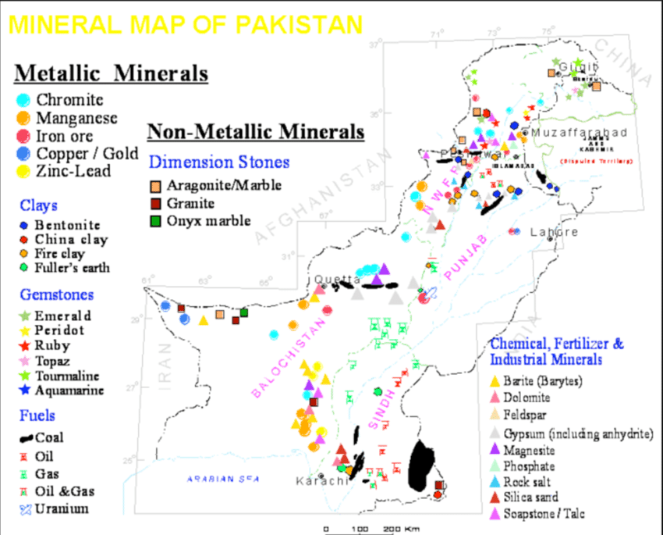
Mining projects in Baluchistan:
- Saindak copper and gold mines project
Location:
- It is located at Saindak at Chinghai district.
- To the north-west of Baluchistan.
- Covering areas of kharan desert.
Companies involved:
- The Saindak copper-gold project was set up by Saindak metals limited, a company fully owned by the government of Pakistan, by the end of 1995.
- Mineral exploration was carried out by two Australian companies.
- Mineral extraction work is carried out by Chinese metallurgical construction company.
- A Chinese company has arranged the fresh water supply by tapping ground water which is sufficient for next 200 years.
- A 50 mw power plant was constructed at Saindak mining site with aid grants from Germany and France.
- German and French aid grants and the Baluchistan government also funded the bulk water supply of 32,000 gallons of daily drinking water, water treatment plant, and warehouse, workshops, laboratories, storage, airport and rail-road link with rcd/eco highway.
Known mineral deposits:
Proven deposits of;
- Gold
- Copper
- Silver
The Saindak mine was estimated to have ore reserves of 412 million tones containing on average 0.5 gram of gold per ton 1.5 grams of silver per ton. According to official estimates, the project has the capacity to produce 15,000 ton of copper annually, containing 1.5 ton of gold and 2.8 ton of silver.
Role of government:
- The government of Pakistan has already taken international loans to make payments to the concern companies involved in the project.
- The Baluchistan government also invested funds in building a township with schools, hospitals, shopping plazas, streets-lighting and water pipelines for over 2000 residents.
- The federal government was to provide funding for operations of the mine through Saindak metals.
- In 2002, the government of Pakistan invited foreign investors to provide funding for the project.
Importance of the project:
- Providing massive employment opportunities to both skilled and unskilled labour force.
- Increasing foreign investments in our country.
- Contributing to foreign exchange earnings by exporting minerals to china and Korea.
- Infrastructural development including road network, power supply, freshwater supply, schools and hospitals for the labour colonies and local population of the district.
Chromite mining in Baluchistan
Locations:
The mines are located in zhob district in Baluchistan, specifically in Muslim bagh, khanozai, nisai and gwal some of the deposits are located in southern Baluchistan near khaddar.
Important chromite mining areas in Baluchistan are:
- Zhob valley is known for its best-known deposits of chromite in Baluchistan.
- Wadh district in khaddar producing high quality chromite.
- Muslim bagh and
- Raskoh range
Companies involved:
- Pakistan chrome mines ltd is a mining company involved in extraction of chromite in Baluchistan province.
Importance of chromite:
- Chromite is an important metallic mineral with high economic value.
- It is used mainly in steel mills for the making of steel
- Total commercial production of chromite in Pakistan is confined only to the province of Baluchistan.
Mining methods:
- Mostly open cast mining method is practiced.
- Few undergrounds (shaft) mines are also producing chromite.
Importance of the project:
- Provides employment to skilled and un-skilled labour force.
- Fulfills local demand of chromite in steel mill at Karachi.
- Reduces import of chromite, thus saves our foreign exchange.
National mineral development policy:
Except oil, gas and nuclear minerals regulated at federal level, the provincial governments are responsible for development and exploitation of minerals. The federal and provincial governments have jointly set out Pakistan’s first national mineral policy in 1995, duly implemented by the provinces. The mineral development policy offered various regulatory and financial incentives to attract foreign investment in the mining sector.
Aims and objectives:
- To increase mineral exploration and extraction in Pakistan.
- To attract multinational companies to invest in the mining sector.
- To offer incentives for mineral exploration.
- Rationalizing import duties on imported mining machinery and equipment.
- To reduce taxation on mining sector and investments.
Reasons for its failure:
The mineral development policy was unable to attract significant foreign investments in the country.
This policy could not be fully implemented in the country due to:
- Lack of finances and working capital.
- Political instability in the country.
- Poor law and order situation in Baluchistan and southern khyberpakhtoonkhwa.
- Delays in setting up of mifa (mineral investment and facilitation authority) both in Sindh and khyberpakhtoonkhwa.
- Lack of government will in formulating and implementing this policy.
Government efforts to the development of mining sector in Pakistan:
- Setting up of institutions and organizations to facilitate mining activity
- Geological survey of pakistan
- Pakistan mineral development corporation
- Gemstone Development Corporation etc.
- Development and extension of infrastructural facilities to the potential mining areas
- Construction of roads
- Power supply from national grid system
- Railway lines
- Fresh water supply through pipelines etc.
- Formulation and implementation of national mineral development policy
- To encourage foreign investment in mining sector
- To reduce taxation on mining activity
- To rationalize import duties on imported mining machinery
- Development of Saindak copper and gold mines project
- To facilitate foreign investors working on the project
- To increase production of metallic minerals in the country
- To increase export of metallic minerals
- To provide employment opportunities for local people
- Establishment of skill development centers in the country
- To increase availability of skilled labour force to mining sector
- To encourage mechanization in mining sector
- To improve quality and quantity of mineral production
Mining and the natural environment:
Impacts on the environment can occur at most stages of mining, from exploration to mine closure and may result from both large-scale and small-scale mining operations.
Impacts of mining activity may affect natural environment including water (hydrosphere), soil (lithosphere), air (atmosphere), biodiversity (biosphere) as well as human health.
Biosphere:
- The open cast method involves rock blasting at the mining site which causes irreversible damage to trees, birds and animals.
- While mining minerals, small-scale miners who are less equipped than industrial miners may inhale contaminated sediments resulting in respiratory and intestinal diseases among them.
- The pollutants enter the food chain through aquatic animals and their predators (bio-accumulation and bio-magnification). Those who eat contaminated fish are at greater risk of ingesting such toxins.
- The forests that are cleared for mining purposes are home to a large number of organisms. Indiscriminate clearing of the forests leads to loss of natural habitat of a large number of animals. This puts the survival of the large number of animal species at stake.
- The cutting down of trees itself is a big threat to a number of plants, trees, birds and animals growing in the forests damaging biodiversity.
- Mining and quarrying are noisy and may use blasting techniques causing noise pollution and driving off wildlife and increasing levels of anxiety among mine workers.
Lithosphere:
- Mining requires large areas of lands to be cleared so that the earth could be dug into by the miners. For this reason, large-scale deforestation is required to be carried out in the areas where mining has to be done.
- Besides clearing the mining area, vegetation in the adjoining areas also needs to be cut in order to construct roads and residential facilities for the mine workers, thus mining is one of the major causes of deforestation and pollution.
- Damaging soils: despite measures being taken to release the chemical waste into the nearby rivers through pipes, a large amount of chemicals still leak out onto the land. This changes the chemical composition of the land and soil.
- Besides this, since the chemicals are poisonous, they make the soil unsuitable for plants to grow.
- Also, the organisms that live in the soil find the polluted environment hostile for their survival.
- Depressions may be caused on the surface due to mineral extraction resulting in natural landscape deformation.
Hydrosphere:
- Chemicals like mercury, cyanide, sulphuric acid and arsenic are used in various stages of mining. Most of the chemicals are released into nearby water bodies and are responsible for water pollution.
- Drainage channels are used to dispose mining waste into the water bodies possibilities of leakage are always there when the leaked chemicals slowly percolate through the layers of the earth, they reach the groundwater and pollute it.
- Release of toxic chemicals into the water is obviously harmful for the flora and fauna of the water bodies.
- Both active and abandoned coal mines sometimes fill with water which becomes highly acidic. During heavy rains, the water may overflow and downstream water courses may become seriously polluted.
Atmosphere:
- The human population brings along with it other activities that harm the environment. For example, various activities at coalmines release dust and toxic gases into the atmosphere.
- Air pollution during mineral extraction and purification process includes dust from mining and acidic gases, carbon dioxide and other greenhouse gas emissions from smelting, refining and other kiln operations.
- Higher levels of pollutants in atmosphere may led to acid rain.
Sustainable mining and measures to control environmental pollution:
While the economic benefits of mining are clearly recognized in Pakistan, concern about the impact of mining on the natural environment has increased. In recent years, both government and the mining industry have recognized this concern, and have acknowledged the importance of their environmental responsibilities by adopting a range of protective measures including:
- Implementation of strict environmental laws to control pollution.
- Soil protection and conservation programmers.
- Development of efficient waste disposal mechanism.
- Afforestation and re-afforestation programmers.
- Protection and conservation of natural habitat.
- Proper monitoring of surface water bodies.
- Filtration of waste gases.
- Proper and regular monitoring of landfill sites.
- Lining and monitoring of waste disposal channels.
- Waste water treatment plants.
- Periodic tuning of mining machinery.
- Ear plugs to control high exposure to noise level.
- Compulsory use of protective clothing, gloves and masks for mine workers.
- Regular health checkups for mine workers.
- Basic educational and recreational facilities to mining colonies
- Entertainment facilities for mine workers.

