Climate of Pakistan

Weather and climate of Pakistan:
Weather:
The atmospheric conditions at any place for a short period are known as weather. Important elements of weather are:
- Temperature
- Pressure
- Winds
- Rainfall
- Humidity
Climate:
The average generalized picture of weather is called climate.
Averages:
Daily range of temperature: Daily max temp-daily min temp
Mean daily temperature: (Daily min temp+ daily max temp)/2
Mean monthly temperature: mean daily temp of 31 days/31
Mean annual temperature: mean monthly temp of 12 months/12
Mean temperature of 10yrs: mean annual temp of 10yrs/10

Generalization:
Making large categories of same characteristic features.
Temperature generalization key Rainfall generalization key
generalization | Temperature range
Very cold | Less than -5°C
Cold | 2°C to -5°C
Cool | 9°C to 3°C
Mild | 20°C to 10°C
Warm | 39°C to 21°C
Hot | 45°C to 40°C
Very hot | More than 45°C
Generalization | Rainfall range
Very arid | Less than 125mm/yr
Arid | 125mm/yr-250mm/yr
Semi-arid | 250mm/yr-750mm/yr
Moist | 750mm/yr-1500mm/yr
Wet | 1500mm/yr -2500mm/yr
Very wet | More than 2500mm/yr
Elements of weather and climate:
Temperature: Temperature refers to the degree of hotness or coldness of atmosphere, generally represented in the degree (°) Celsius or Fahrenheit.
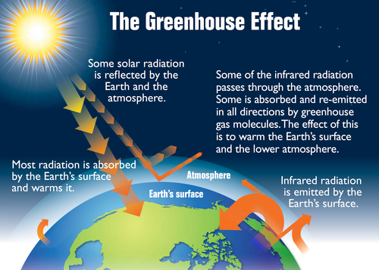
Energy balance between incoming and outgoing radiation:
The atmosphere absorbs or reflects about half of the solar energy reaching the earth. Most of the energy reemitted from the earth’s surface is long wave, infrared energy. Most of this infrared energy is absorbed by aerosols and gases in the atmosphere and is re-radiated toward the planet, keeping the surface much warmer than it would otherwise be. This is known as greenhouse effect.
Factors affecting atmospheric temperature in Pakistan:
Latitudinal effect:
Insolation is the single most important influence on temperature equations. In general, areas around equator (0° latitude) are hotter while north and south poles (90°N/S) are the cold regions of the earth. This means increasing degrees of latitudes i.e. moving from 0° to 90° N and S the atmospheric temperature decreases. In other words moving from equator towards poles, the atmospheric temperature falls down. In Pakistan, southern areas (23.5°N) are close the equator thus warmer while northern areas (37°N) are away from equator, thus cooler
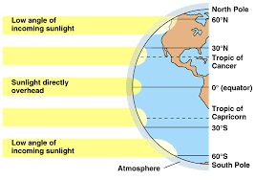
Effect of altitude:
In general with increasing altitude from sea level the atmospheric temperature falls down. At high elevation, there is less atmosphere above the surface, and greenhouse gases provide a less effective insulating blanket. More surface heat is lost to space. The rate of decrease in atmospheric temperature with increasing altitude is called normal lapse rate. On an average basis, it is calculated as -6.5°C/1000m above mean sea level as shown in the figure.

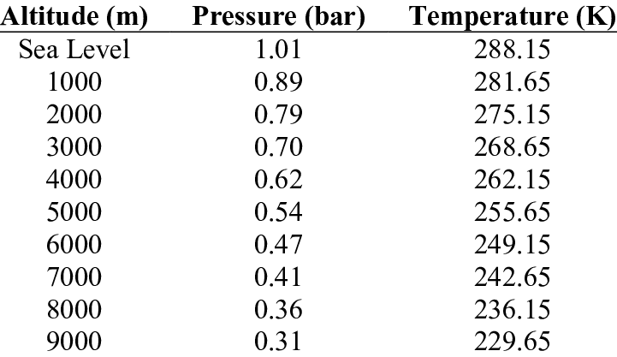
In Pakistan, southern areas are close to sea level due to Arabian Sea thus warmer while northern areas are at higher altitude of nearly 6000m due to Karakorum and Himalayan mountains thus cooler.
Maritime influence: In general, it is described as the “effect” of large water bodies on the atmospheric temperature of adjoining coastal areas i.e. large water bodies tend to normalize the atmospheric temperature of adjoining coastal areas through sea breeze and land breeze.

In southern Pakistan, Arabian sea effects the temperature of coastal areas of Sindh and Balochistan where atmospheric temperature remain tolerable throughout the year i.e. neither very hot in summer, nor cold in winters, but warm summers and cool winters.
Continental effect: It is described as the effect of extensive land mass on the atmospheric temperature of adjoining areas. The interior part of the continents, located away from large water bodies experience extreme temperature i.e. very hot summer temperatures. In Pakistan, continental effect is affecting most areas of lower Punjab and upper Sindh province.
Vegetation cover: In general, vegetation cover helps controlling temperature by absorbing CO2 from the atmosphere, which is an important greenhouse gas and is mainly responsible to maintain and now increase temperature of our atmosphere
Vegetation cover= 1/concentration of CO2 OR 1/atmospheric temperature
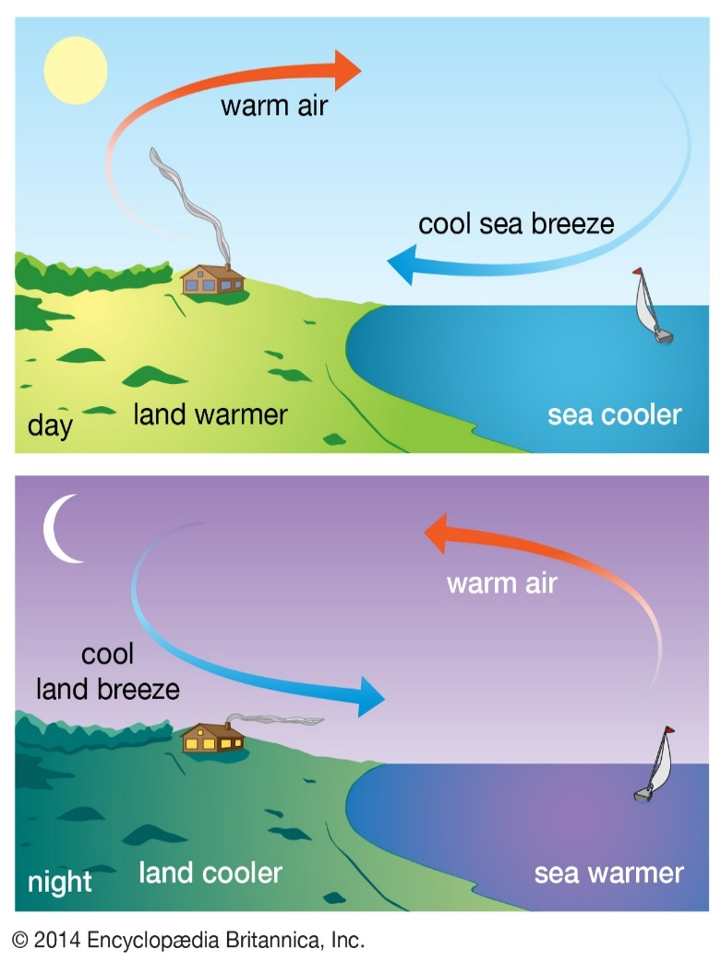
Land breeze:
- At night, the land cools faster than the nearby ocean surface
- Radiant heat energy is lost more rapidly from the land than from the sea
- Warm moist air close to the ocean surface rises
- Cool air from the land moves offshore to replace the rising air. A cool offshore land breeze is generated at night.
- Aloft an onshore airflow descends to complete the cycle.
Sea breeze:
- On a bright sunny day the land warms up more quickly than the nearby surface water of the sea
- Dry air close to the land surface warms quickly and rises
- Cool moist air close to the sea surface moves ashore to replace the rising air. A cool onshore sea breeze is thus generated during the day.
- Aloft an offshore airflow descends to complete the cycle.
In Pakistan generally, northern region has more dense vegetation and forest cover as compared to southern region. Thus, northern regions are cooler compared to southern regions of the country.
Comparison between temperature conditions of sukkur and muzzafarabad:
Sukkur | Muzzafarabad
Located in upper Sindh, on lower indus plain | Located in upper pakistan, on lesser Himalayas
Experience high temperature | Experiences lower temperature
Low altitude area with an average altitude of 500-1000m above sea level | High altitude region with average altitude of 4000m above sea level
Low altitude region around 28°N of equator | Upper latitude region-around 34°N of equator
Experiences continental effect | Does not experiences continental effect
Sparse vegetation, mostly dry shrubs and grasses | Dense vegetation cover due to coniferous forest
Precipitation:
It refers to the total amount of moisture that reaches to the earth surface from upper atmosphere.
Types of precipitation
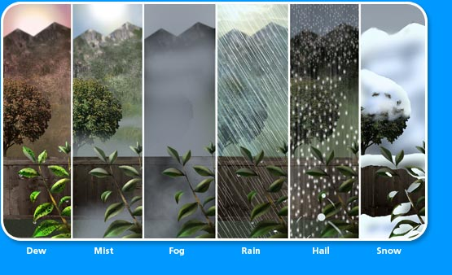
Factors affecting rainfall in Pakistan:
- Monsoon winds: A monsoon is a seasonal wind. The word is also used to describe the season in which the wind occurs.
How are monsoon winds formed?

Comparison between primary and secondary summer monsoon winds/rainfall
Similarities
Winter monsoons:
- During the winter, landmasses cool more quickly than adjacent oceans resulting in air masses moving from the land out over the ocean
- The temperature difference between the land and the ocean is not as extreme as it is during the summer, so the winds are not strong or constant.
- These winds are mostly dry, and chilled in nature.
Summer monsoons:
- The Asian summer monsoon carries warm moist air from the ocean to adjacent landmasses. It is similar to a sea breeze except that it is much stronger, affects a wider area, and is much more constant.
- Monsoons are caused by the fact that landmasses heat up and cool down more quickly than oceans do.
- During the summer, this process causes air masses over the land to heat up and rise, creating a low-pressure zone. Air, laden with moisture, flows from the oceans into this low-pressure zone. Where this air encounters uplands, it is forced to rise and release its moisture as heavy precipitation.

primary summer monsoons | Secondary summer monsoon
Timing- July to September | Timing- July to September
Originates from sea/water body | Originates from sea/water body
Brings rainfall to pakistan | Brings rainfall to pakistan
Air rises along the mountains | Air rises along the mountains
Clouds are formed | Clouds are formed
Moves from high pressure to low pressure | Moves from high pressure to low pressure
Highly variable wind system | Highly variable wind system
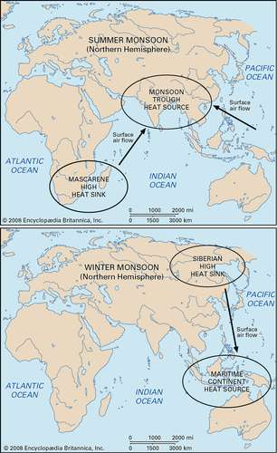
Differences
primary summer monsoons | Secondary summer monsoon
Originates from bay of Bengal | Originates from the Arabian sea
Winds blow towards the north | Winds blow towards the north east
Tail end enters after crossing India and Bangladesh | Winds enter directly to pakistan
Brings rainfall to north and north eastern parts of pakistan | Brings rainfall to south and south eastern parts of pakistan
Generally more stronger in terms of amount and intensity | Generally weaker system than the primary summer monsoon
SUMMER PRIMARY MONSOON: EXPLANATION:
- During summer month i.e. July, august and September
- High temperature on land/upper pakistan
- Low pressures on bay of Bengal because of water takes more time to heat up and develops high system on bay of Bengal
- Low pressure on land attracts high pressure, moisture laden winds from bay of Bengal
- Winds blow from Bay of Bengal to northern Pakistan. After crossing India and Bangladesh; the tail end of monsoon system reaches to north eastern highlands of pakistan
- Moisture laden winds rise along the slope of northeastern mountains. At higher altitudes condensation takes place due to lower temperature
- Clouds are formed and heavy rainfall takes place
Summer monsoon:
Primary monsoon features:
- TIMING: JULY, AUGUST, SEPTEMBER
- SOURCE: BAY OF BENGAL
- VIA: INDIA AND BANGLADESH
- DIRECTION: SOUTH EAST
- NATURE: STRONG WINDS, RICH IN MOISTURE, HIGHLY VARIABLE RAINFALL
- DISTRIBUTION: MOVING SOUTHWARD OF PAKISTAN, POTWAR PLATEAU, UPPER INDUS PLAIN INCLUDING NORTHERN AND CENTRAL PARTS OF PUNJAB
- TREND: MOVING SOUTHWARD THE AMOUNT AND INTENSITY OF PRIMARY MONSOON RAINFALL DECREASES
WINTER MONSOON: EXPLANATION:
- During winter month i.e. December and January
- Low temperature on land i.e. Siberia because land loses energy quicker
- High pressures develops on land because temperature and pressure are inversely proportional
- High pressure on Indian ocean because water stores energy for longer
- Low pressure on sea because temperature and pressure are inversely proportional
- Low pressure attracts chilled Siberian winds which blow towards Arabian sea/pakistan in south west direction
- Northern mountain act as a barrier and protect pakistan from chilled Siberian winds
- Winter temperature is tolerable on indus plain thus rabi/winter crops can be grown there

Winter monsoon: features
TIMING: DECEMBER, JANUARY, FEBRUARY, MARCH
SOURCE: SIBERIAN DESERT
VIA: CHINA AND TAJIKISTAN
DIRECTION: NORTH AND NORTH EAST
NATURE: DRY, CHILLED, STRONG SIBERIAN WINDS
DISTRIBUTION: NORTHERN HIGHLANDS OF PAKISTAN

SUMMER SECONDARY MONSOON: EXPLANATION:
- During summer month i.e. July, august and September
- High temperature on land/ pakistan due to high insolation
- Develops low pressures on land/ lower pakistan
- Low temperature on Arabian sea because water takes more time to heat up
- Develops high pressure system on Arabian sea
- Low pressure on land attracts high pressure moisture laden winds from Arabian sea
- Winds start to blow from Arabian sea to pakistan
- Moisture laden winds rise along the slopes of the highlands
- At higher altitudes condensation takes place; clouds are formed and heavy rainfall occurs
Summer monsoon:
Secondary monsoon features:
- TIMING: JULY, AUGUST, SEPTEMBER
- SOURCE: ARABIAN SEA
- VIA: DIRECTLY TO PAKISTAN
- DIRECTION: SOUTH WEST
- NATURE: COMPARATIVELY WEAKER WIND SYSTEM, RICH IN MOISTURE, ASSOCIATED WITH RAINFALL HIGHLY VARIABLE RAINFALL
- DISTRIBUTION: COASTAL AREAS OF SINDH AN BALOCHISTAN, SOUTH EASTERN DESERT OF PAKISTAN, MOST PARTS OF LOWER INDUS PLAIN IN SINDH
- TREND: MOVING NORTHWARD THE AMOUNT AND INTENSITY OF SECONDARY MONSOON RAINFALL DECREASES
Western depressions:
WESTERN DEPRESSION: EXPLANATION:
- During winter month i.e. December, January, February and march
- Low temperature in pakistan due to winter season
- Leading to development of high pressure on land in pakistan
- Very low pressure on mediterrian sea
- Pressure differences created between land and mediterrian sea
- Low pressure on land attracts high pressure, moisture laden winds on mediterrian sea
- Wind to blow eastward on land
- After crossing Afghanistan and Iran where it loses most of its moisture, the western depression reaches to western highlands of pakistan
- Moisture laden winds rise along the slopes of western highlands
- At higher altitude, condensation takes place, clouds are formed and rainfall occurs
Western depressions: features:
- TIMING:DECEMBER,JANUARY, FEBURARY, MARCH
- SOURCE: MEDITERRIAN SEA
- VIA: IRAN AND AFGHANISTAN
- DIRECTION: WEST
- NATURE: PERSISTENT, RELIABLE, TIMELY
- DISTRIBUTION: NORTH WESTERN AND WESTERN HIGHLANDS OF PAKISTAN, POTWAR PLATEAU, WESTERN PARTS OF BALOCHISTAN PLATEAU, BALOCHISTAN COAST AND PARTS OF SINDH COAST
- TREND: MOVING EASTWARD THE AMOUNT AND INTENSITY OF WESTERN DEPRESSION DECREASES

Timings are from December-march | Timings are from December-march
brings precipitation to highland areas | brings precipitation to highland areas
Compare between the winter monsoon and the western depression winds/rainfall:
Similarities:
Differences:
Originates from mediterrian sea | Originates from Siberian desert
Winds enter from west | Winds enter from north east
Carries moisture along | A little or no moisture
Brings precipitation mostly in the form of rainfall | Brings precipitation mostly in the form of snowfall
Brings rainfall to western highlands | Brings snowfall to northern highlands
Comparison between summer monsoon and western depressions rainfall/ winds
Similarities:
Brings rainfall to pakistan | Brings rainfall to pakistan
Moves from high pressure areas to low pressure areas | Moves from high pressure areas to low pressure areas
Moisture laden winds | Moisture laden winds
Winds condense in highlands | Winds condense in highlands
Originates from large water bodies(sea) | Originates from large water bodies(sea)
Travels and loses moisture on land before reaching pakistan | Travels and loses moisture on land before reaching pakistan
Tail end reaches pakistan | Tail end reaches pakistan
Differences:
Timings from July-September | Timings from Dec-mar
These winds move from south east to south west | These winds move from west to eastward
Brings rainfall to southern and north eastern pakistan | Brings rainfall to western and north western highlands of pakistan
Brings heavy showers of rainfall | Brings light frequent showers of rainfall
Highly variable system | reliable system of rainfall
Originates from bay of Bengal and Arabian sea | Originates from mediterrian sea
Enters pakistan after crossing India and Bangladesh | Enters pakistan after crossing Afghanistan and Iran
Convectional rainfall:
Convectional rainfall: features:
- TIMING: APRIL, MAY, JUNE (1st MAJOR) AND OCT, NOV (2ND MINOR)
- SOURCE: LOCAL WATER BODIES AND VEGETATION COVER
- VIA: LOCAL SYSTEM DEVELOPS WITHIN PAKISTAN
- DIRECTION: CONVECTIONAL CURRENTS MOVE VERTICALLY UPWARD
- NATURE: TORRENTIAL, HEAVY RAIN
- DISTRIBUTION: NORTHERN AND NORTH WESTERN HIGHLANDS OF PAKISTAN, POTWAR PLATEAU AND UPPER PUNJAB
- TREND: MOVING SOUTHWARD THE AMOUNT AND INTENSITY OF CONVECTIONAL RAINFALL DECREASES
Convectional rainfall: EXPLANATION:
- During early summer and post monsoon season temperature rises in pakistan
- High temperature leads to high rate of evaporation and evapotranspiration
- Heat currents carry water vapors and move vertically upwards
- Low temperature on higher altitude leads to condensation
- Clouds are formed at higher altitude
- Heavy rainfall associated with lightening hails and thunderstorms occur

Relief rainfall:
Relief rainfall: EXPLANATION:
- Water bodies and vegetation cover lead to evaporation and evapotranspiration
- Moving winds carry moisture along towards the highlands in the north
- The moisture laden winds rise along the windward slopes of the mountains
- Rising wind reaches to condensational level
- Clouds formed at higher altitude
- Heavy rainfall occurs on the windward slopes of the mountains
- Areas of windward slopes are called rain fed or barani areas where farming depends only on rainfall
- After relief rainfall dry winds/ chinook winds descend on leeward slopes of the mountains
- Leeward slopes are called rain shadow areas
Relief rainfall: features:
- TIMING: THROUGHOUT THE YEAR BUT PROMINENT IN OCT, NOV
- SOURCE: LOCAL WATER BODIES AND VEGETATION COVER
- VIA: LOCAL SYSTEM DEVELOPS WITHIN PAKISTAN
- DIRECTION: WINDWARD SLOPES OF THE MOUNTAINS
- NATURE: TORRENTIAL, HEAVY RAIN, ASSOCIATED WITH LIGHTENING
- DISTRIBUTION: NORTHERN AND NORTH WESTERN HIGHLANDS OF PAKISTAN, POTWAR PLATEAU
- TREND: NO RELIEF RAINFALL IN SOUTHERN PAKISTAN

Natural hazards:
- River floods:
Definition: Condition in which a river channel overflows and inundates the nearby areas
OR
A flood is an overflow of an expanse of water that submerges land.

Affected areas: Active flood plains and old flood plains of river Indus and its tributaries and mountain valleys are affected by flash floods

Timing: Mainly summer and post monsoon months of July, august, September and October.

Reasons:
Natural factors:
- Heavy monsoon rainfall in northern parts of pakistan
- Excessive melting of glaciers and snow in the northern pakistan due to high summer temperature and global warming
Human factors:
- Breakdown of artificial levees on the sides of rivers
- Higher rate of deforestation on the mountain slopes
- Increased rate of siltation in dams, canals and river channels
How to control river floods:
- Construction of dams to store water
- Construction of new strong levees and strengthening the previous ones
- Afforestation on the slopes of the northern mountains
- Installing silt traps on the mountain slopes to control silt and reduce soil erosion
- Land use planning on modern lines means no dense human settlements/population on active flood plains
- Monitoring river levels during monsoon season
- De-siltation of canals and widening of river channels/ dredging
- making flood canals and diversion channels
- improved flood warning system
- evacuation of flood affected areas
Advantages of floods:
- ground water recharge
- spread of alluvium(fertile, nutrient rich soil) on UIP and LIP
- surface water reservoirs replenished (dhands/dhorous and tobas)
- diversion of flood water to desert areas can increase agricultural productivity
- Nutrient rich water when reaches to the delta it attracts plenty of fish and encourages fishing industry
- Flood water helps in growth of delta
Disadvantages of floods:
- Loss of human lives
- Loss of livestock’s
- Loss of crops
- Property loss-damaging houses and settlements
- Loss of transport infrastructure-roads and railways
- loss of communication infrastructure- telephone lines
- loss of power infrastructure- power transmission lines, electric poles, transmission pylons, grid stations and power stations
- contaminate the scarce clean, drinking water
- unhygienic conditions spread water-borne diseases
- shortage of food crops can be caused due to loss of harvest, however, lowlands near rivers depend upon river silt deposited by floods in order to add nutrients to the local soil
- non tolerant species can die due to suffocation
- transport links destroyed, so hard to get emergency aid to those who need it
- economic hardship due to temporary decline in tourism, rebuilding cost and inflation of food crop price
- Storms:
- tropical cyclones:
Definition: It is a storm system characterized by a low-pressure center and numerous thunderstorms that produces strong winds and heavy rain
Affected areas: Mainly on the eastern parts of Sindh coast near Indus delta, occasionally on makran coastal areas.
Timings: Usually formed during the summer months from late April till June and then from late September till November
Reasons:
- Tropical cyclone are formed over the ocean in the area around the equator, between the tropic of cancer and the tropic of Capricorn. When low-pressure system develops on the Arabian Sea it moves towards the coastal areas of Sindh and Balochistan, associated with strong winds and heavy rainfall.
Effects:
Disadvantages:
- The main effects of tropical cyclones include heavy rain, strong winds, large storm surges at landfall and tornadoes
- The destruction from a tropical cyclone depends mainly on its intensity, size and location
- Tropical cyclones act to remove forest canopy as well as change the landscape near coastal areas, by moving and reshaping sand dunes and causing excessive erosion along the coast
- Even well inland, heavy rainfall can lead to mudslides and landslides in mountain areas
- After the cyclone has passed, devastation often continues, strained water can cause the spread of water borne diseases
- Transportation and communication, infrastructure may have been destroyed, hampering clean up and rescue efforts
- Loss of human lives
- Loss of property including houses and settlements of fishing communities
- Loss of agricultural production near badin regions
- Loss of livestock
- Shortage of food and fodder
- Can damage the wind power panels installed near the coast in lower Sindh area
Advantages:
- Despite their devastating effects, tropical cyclones are also beneficial by potentially rainy to dry areas and moving heat from the tropics to pole wards.
- Surface water reservoirs can be replenished
- Inland fishing ponds or reservoirs near the coast can get sufficient water
- Availability of water in drought affected areas in lower Sindh
- Out at sea, ships take advantage of their known characteristics by navigating through their weaker, western half.
Dust storms:
Definition: Dust storms are created by the intense heating of the desert areas where an intense low pressure develops due to heating of the ground, temporarily this low-pressure system in desert areas, attracts wind from nearby areas. These strong winds pickup sand and dust and dust storm is created.
Timings: It usually develops during the summer and early summer season from May to July.
Problems/disadvantages of dust storms:
- Intense heat wave makes it difficult to carry out outdoor activities
- It can create shortage of water by increasing the rate of evaporation from the ponds and reservoirs
- Movement of people restricted due to intense heat and strong dusty winds
- Transport links including roads can get blocked or their service might get suspended

- Droughts
Definition: Unusual shortage of rainfall leading to severe shortage of surface and groundwater.
OR
A drought is an extended period of months or years when a region observes a deficiency in its water supply whether surface or groundwater. Generally, this occurs when a region receives consistency below average precipitation.
Types of droughts experienced in Pakistan:
- Permanent drought: It is the permanent shortage of rainfall in the northwestern balochistan, kharan district where mean annual rainfall is less than 125mm.
- Seasonal drought: Limited rainfall in summer monsoon season whereas rest of the year remains dry. Usually occurs in the southeastern desert of Pakistan including cholistan, Nara and tharparkar.
- Unpredictable droughts: mainly due to uncertainty of monsoon rainfall in lower Punjab and LIP.
- Invisible droughts: Comparatively lesser agricultural production due to shortage of fresh water in the margins of LIP in southern Sindh.
Distributed of droughts in affected areas:
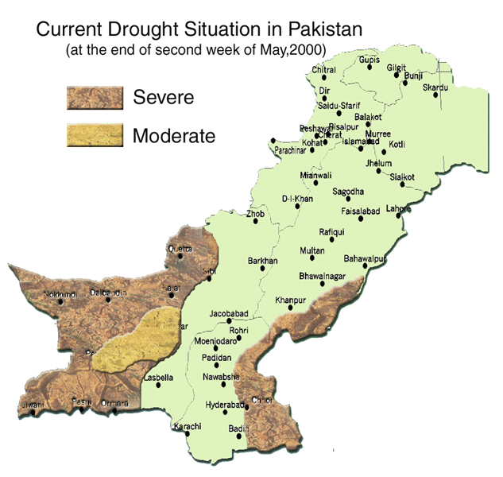
Effects/consequences of droughts:
- Diminished crop growth or yield, productions and carrying capacity for livestock
- Dustbowls, themselves a sign of erosion, which further erode the landscape
- Dust storms, when drought hits an area suffering from desertification and erosion
- Famine due to lack of water for irrigation
- Natural habitat damage, affecting terrestrial wildlife
- Malnutrition, dehydration and other related diseases among the people
- Mass migration, resulting in internal displacement and international refugees
- Reduced electricity production, due to reduced water flow through hydroelectric dams
- Shortages of water industrialisers
- Social unrest due to sudden increase in migration
- Regional disputes over natural resources like water and food
Drought protection:
Dams | Many dams and their associated reservoirs supply additional water in times of drought
Cloud seeding | An artificial technique to induce rainfall
Desalination plants | Desalination of sea water for irrigation or consumption
Drought monitoring | Continuous observation of rainfall levels and comparisons with current usage levels can help prevent man made drought
Land use | Carefully planned crop rotation can help to minimize erosion and allow farmers to plant less water dependent crops in drier years
Outdoor water use restriction | Regulating the use of sprinklers, hoses or buckets on outdoor plants, filling pools and other water intensive home maintenance tasks
Rainwater harvesting | Collection and storage of rainwater from roofs or other suitable catchments
Recycled water | Former fresh water sewage that has been treated and purified for reuse
Irrigational canals | Building canals or redirecting rivers as massive attempts at irrigation in drought-prone areas
Afforestation | More trees must be planted in order to increase natural rainfall and avoid soil erosion
4.Earthquakes:
Definition: An earthquake is the result of a sudden release of energy in the earth’s crust that creates seismic waves.
Effects of earthquakes:
- Shaking and ground rupture are the main effects created by earthquakes, principally resulting in more or less severe damage to buildings and other rigid structures
- Ground rupture is a major risk for large engineering structures such as dams, bridges and nuclear power stations.
- Earthquakes, along with severe storms, volcanic activity, coastal wave attack and wildfires can produce slope instability leading to landslides.
- Landslide danger may persist while emergency personnel are attempting rescue
- Large waves produced by an earthquake can cause tsunami
- Earthquakes can cause fires by damaging electrical power or gaslines
- Floods may be secondary effects of earthqaukes if dams are damaged.
- It may cause loss of life, transport, property and collapse or destabilization of buildings
- Soil erosion:
Definition: It occurs when soil is removed through the action of wind and water at a greater rate than it is formed.
Factors affecting soil erosion:
- The intensity of rainfall (erosivity)
- Nature of soil (erodibility)
- Length and steepness of slope
- Presence of natural vegetation on the slope
- How land is used and managed
- Grazing by animals
Affected areas of soil erosion:
- Widespread in northern areas
- Western ranges including waziristan, sulaiman and kirthar ranges
- Highlands of southwest balochistan
- South and south eastern areas in sindh
High risk of soil erosion in dry and arid areas due to:
- bare soil/lack of vegetation cover
- slow or limited growth rate of natural vegetation
- loose and dry soil can be easily eroded through wind and water
- strong winds and heavy rainfall

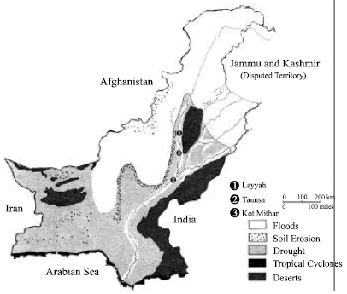

Consequences of soil erosion:
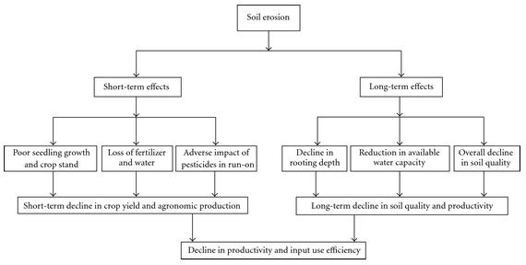
Destination of eroded soil:
- wind blown into dunes
- accumulates on the foothills of the mountains
- into rivers, canals, minor canals/channels and finally into arabian sea
- into reservoirs, dams and lakes on land
- spreads on active and old flood plains as alluvium
protection of soil:
- shelter belts, plantations and afforestation on hill slopes
- irrigated plantations
- prevent overgrazing
- discourage open grazing on thin grass
- filling gullies
- improved cultivation methods to avoid exposure of loose soil-shelter plants contour ploughing to stop water from flowing, crop rotation, plating nitrogen fixing plants (pulses), use of manure, strip farming i.e. growing different crops on lands, etc.
- terracing on hill slopes
- stone lines around the fields
- reducing gradient on foothills and hillslopes

