Introduction and natural topography

Land and location of Pakistan:
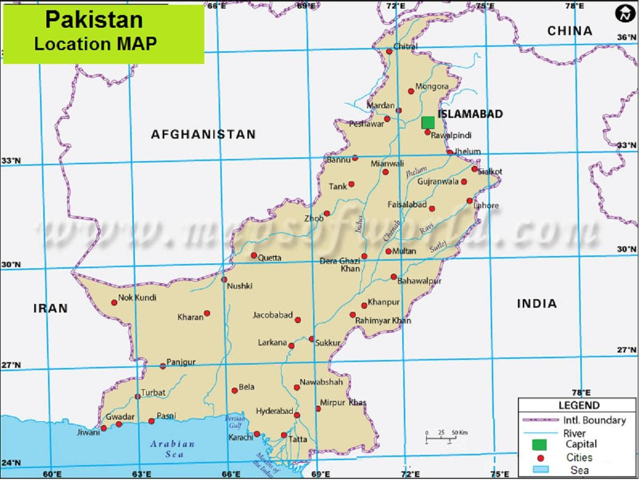
Key to rivers:
- Indus 6. Mastuj 11. Hab
- Jhelum 7. Kabul 12. Hingol
- Chenab 8. Kurram 13. Dasht
- Ravi 9. Gomal 14. Kech
- Sutlej 10. Zhob 15. Nihing
Absolute location:
Latitudes: 23°N-35°N
Longitudes: 61°E- 76°E

REFERENCES TO LATITUDES:
- 23.5°N tropic of cancer touches the southern tip of Pakistan
- 28°N separates Sindh and Punjab
- 32°N separates KPK and Balochistan
- 36°N divides gilgit into two lateral halves

REFERENCES TO LATITUDES:
- 68°E runs nearly parallel to river indus on LIP
- 72°E runs from west of Gilgit
- 74°E divides gilgit into two vertical halves
- 76°E runs from the east of gilgit

Neighboring countries:
- Afghanistan (2252 km)
- China (585km)
- India (1600km)
- Iran (858km)
- Arabian sea (997km)

Physical regions of Pakistan:
- Mountains
- Plateaus
- Plains
- Deserts

Physiography:
Naturally occurring physical features e.g. mountains, plains, lakes, rivers, etc. and the study or description with the help of maps, charts and diagrams, etc.
Topography:
Physical features on the surface of the earth e.g. mountains, dams, barrages, rivers and settlements, etc. and its study or description with the help of maps, charts and diagrams, etc.
Topography: relief + drainage

Relief features:
- Location
- General terrain
- Mountains:
- Names
- Extensions
- Average height
- Highest peak- name and altitude
- Plateuas
- Plains
- Depressions/basins
- Deserts
- Passes
- Glaciers:
- Name
- Length
- Associated river
- Valleys
Drainage features:
- General slope of the land
- Name
- Nature- seasonal or perennial
- Source: glacier melt, rainfall or both
- Destination- inland, tributary or into open sea
- Lakes:
- Name
- Nature- seasonal(salty or brackish) or permanent (fresh water)
- Glaciers:
- Name
- Length
- Associated river
- Valleys

Mountains of Pakistan:
- Northern mountains:
- Karakoram range
- Hindu Kush range
- Himalaya (central, sub and lesser Himalayas)
- Western mountains:
- Safed koh range
- Waziristan Hills
- Suleiman range
- Kirthar range

Northern mountains:
Relief features:

Karakoram Range:
Location:
In extreme north of Pakistan, bordering China in the north and north east.
General terrain/outcrop of the land/ appearance:
Rugged landscape, characterized by snow-capped sharp peaks, towering mountains and V-shaped steep sided valleys and cirques. The range stretches in east-west direction for 500km between Hunza and Shyok rivers. Average height of the range is 6000m above sea level. The highest peak of the range is Godwin Austin (K2) with an altitude of 8611m above sea level. Some of the largest and famous glaciers of the range include Siachen glacier (78km long drained by Braldo River), Biafo glacier (72km long drained by Shyok River) and Hispar glacier (71km long drained by Shyok River). Important passes of the range include Karakoram pass and Khunjerab pass.
Hindu Kush range:
Location:
In the west of Karakoram Range and in the north west of Pakistan, bordering Afghanistan.
General terrain/outcrop of the land/ appearance:
Rugged landscape, characterized by snow-capped sharp peaks mostly during the winter season. It stretches from the Pamir plateau in north east to south west direction. Average height of the range is 5000m above mean sea level. The highest peak of the range is Trich Mir with an altitude of 7690m above sea level. The range is also covered by a number of glaciers including Trich Mir, Kotgaz and Niroghi glacier. Important passes of the range include Baroghil Pass, Shandur Pass and Lawari pass.
Himalayas:
Location:
To the south of Karakoram Range.
General terrain/outcrop of the land/ appearance:
Rugged landscape, characterized by snow-capped sharp peaks, towering mountains and steep sided valleys. Himalayas stretches in the east west direction. Average altitude of the range is 4000m above mean sea level. It is further divided into three parallel ranges based on the altitudes:
- Central Himalayas-average altitude 4500m-6000m above mean sea level
- Lesser Himalayas- average altitude 1800m-4500mabove mean sea level
- Siwaliks- average altitude 600m-1200m above mean sea level
The highest peak of the Himalayas is called Nanga Parbat with an altitude of 8126m above sea level. Himalayas are also covered with a number of glaciers like rupal (north and south).

Drainage features:
Karakoram Range:
The drainage slope of the Karakoram Range is generally in the south west direction. Important rivers of the Karakoram Range are river Indus, river shyok, river hunza and river gilgit, etc. Indus is the largest perennial river which receives water from glacier melt, monsoon rainfall and other small seasonal streams which drain into Indus.
River shyok, river hunza, river gilgit and river braldo are the important seasonal rivers of the range which flow mostly during summer season carrying water from summer monsoon rainfall and glacial melt and finally drain into the river indus. One of the largest glaciers of Pakistan lies in the Karakorum Range including Siachen glacier (78km long drained by Braldo River), Biafo glacier (72km long drained by Shyok River) and Hispar glacier (71km long drained by Shyok River), Balturo glacier (58km long drained by Hunza River) and Batura glacier (58km long drained by Hunza River). Important mountain valleys of Karakoram Range include gilgit valley, Hunza valley and Baltistan valley.
Hindu Kush range:
The drainage slope of the hindukush range is generally in southward direction. Important seasonal rivers are river kunhar, river panjokara, river ghizar, river swat and river Mastuj. River kunhar, river panjokara, and river swat drain in river Mastuj which eventually drains in river Indus. All the rivers are seasonal in nature and flow mostly during winter season carrying water from western depression rainfall. The longest and important glacier include Sakiz jarab glacier which is 30km long and drained by river Kunhar. Other important glaciers are Trich Mir glacier and rich glacier drained by river kunhar. Important mountain valleys are swat valley, chitral valley and Dir valley.
Himalayas:
The drainage slope of Himalayas is usually in southward direction. Important seasonal rivers include river neelum and river kaghan while river Indus is only Perennial River flowing in the south-west direction through the mountains. All seasonal rivers flow during summer season carrying water from summer monsoon rainfall and glacial melt water. Important glaciers include Rupal (north and south) and phangaton glacier which eventually drain their water into river indus. important valleys are kaghan valley, naran valley and shogran valley. Important gullies with tourist attractions include murree, nathiagali and ghoragali.

Human economic activities in northern mountains:
Lumbering: it refers to the extraction of wood from the forests which is an important and common economic activity of the people living in northern areas of Pakistan. Lumbering is carried out to:
- Obtain fuel wood for domestic heating and cooking purpose
- Obtain commercial wood or timber for furniture industries
Fishing: Small scale fresh water fishing is carried out in Kunhar River, Swat River and Kaghan River. Trout fish is considered a delicacy and is very famous among the tourists visiting the valleys.
Crop farming: Small scale subsistence crop farming is another economic activity which is carried out mostly on terraced fields and valley floors where water is available from rivers and temperatures remain mild to warm. Mostly food crops are grown including wheat, rice, barley, millets, etc.
Livestock farming: Small scale livestock farming is practiced in mountainous areas in order to obtain meat, milk, wool and other by-products. Common animals include goat, sheep, yak, dzu, cows and mules.
Fruit farming: Another important economic activity of the people is fruit farming both on subsistence and commercial level. Common fruits grown in the orchids, along the road sides and on valley floors include apples, apricots, plums, peaches, almonds and walnuts. Fruits not only provide nutrition and vitamins to the local population but they are also supplied to large cities like Islamabad, Lahore, Faisalabad and Karachi.
Industries: Inhospitable climatic conditions and poor infrastructure facilities like transport and communication links mark this area inaccessible for most part of the year as a result many people are engaged in cotton/craft industry like carpet weaving, embroidery, candle making, etc.
Tourism: A large number of people are engaged in tourism industry as tourist guides and in other associated businesses such as hotel industry, transport industry, and even they work in small seasonal villages.
Transhumance: People of northern mountains usually live semi nomadic lives called transhumance which can be classified as a type of seasonal migration and as a type of livestock farming. Mountain people move to the plains and valleys during winter season along with their livestock and belongings and they again move back to the mountain summer season.

Why do the mountain people move to plains/valleys during winter season?
- To protect themselves from severely cold winter i.e. 0 degree in the mountains.
- No outdoor economic activities possible due to cold.
- Area covered by snow with frozen top soil thus agriculture is not possible.
- Avalanches are very common during winter season
- All streams are frozen and covered with thick snow thus creating shortage of liquid water
- To protect their animals from severe cold winter conditions that could be fatal to them
- Grazing lands and pastures are covered with thick snow thus creating a shortage of fodder

Why do mountain people move back to mountains during summer season?
- Pastures locally called Shamilats are replenished with nutritious grass for livestock
- They have their native homes and farming lands on the mountains
- They can grow crops on their farming lands or on the mountains
- They can grow crops on their farming lands or on the terraced fields
- Streams start to flow again providing water for domestic use, agriculture and livestock needs
- Summer temperature is quite tolerable that is mild to warm for agriculture and other outdoor activities
- More seasonal employment opportunities created due to tourism industry and other associated businesses on the mountains.

How do they earn a living/survive on plains/valleys?
- They perform temporary jobs
- Self-employed in informal business activities such as vegetable seller or street hawker etc.
- They use meat, milk and other by products from their livestock
- These products can be sold to earn money
- Some time they sell their animals to make money

Environment and development in northern areas:

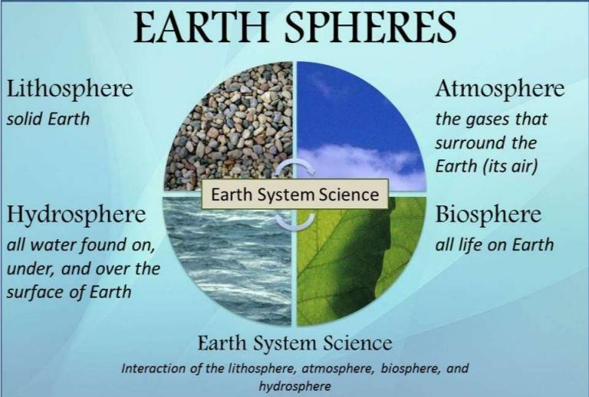
Atmosphere:
Urbanization ⇨deforestation ⇨more CO2⇨rising temperature ⇨disruptive water cycle
Urbanization ⇨more population⇨ more vehicles⇨ more emissions of CH4 and CO2
Hydrosphere:
Urbanization⇨ deforestation ⇨surface run off⇨ more sediments in streams ⇨turbid streams
Increasing population ⇨more domestic waste⇨ dumping into rivers and streams
Dumping domestic waste upstream⇨ water pollution⇨ drinking polluted water downstream⇨ acute chronic diseases⇨ dysentery, typhoid, cholera, etc.
Lithosphere:
Urbanization⇨ new settlements⇨ new roads⇨ deforestation ⇨soil exposure ⇨erosion
Increasing population ⇨unplanned settlements ⇨deforestation ⇨soil erosion
Biosphere:
Increasing population ⇨roads and settlements ⇨deforestation ⇨loss of natural vegetation
Urbanization⇨ deforestation ⇨loss of natural habitat ⇨wild life extinction

Economic importance of northern mountains:
- The northern mountains act as a natural barrier and the concerned countries accept it as an international border
- These mountains also protect the plain areas of our country from the cold winds of central Asia during winter
- As these mountains are situated across the direction of wind, so they intercept the summer monsoon winds coming from the Arabian sea and the bay of Bengal, which becomes the cause of rainfall
- The high peaks of northern mountains become snow covered during winter, the snow melts during spring and summer and feeds water into the rivers of our country
- Several rivers like Indus and its tributaries originates from these ranges and during rainy season they carry enormous qualities of water which is used for irrigational purposes on plains.
- Mountainous terrains with fast flowing rivers of northern mountains helps construction of dams and production of HEP.
- On the southern slopes of northern mountains are found magnificent and very valuable forests of timber besides, on these slopes a number of fruit trees are also cultivated which fulfil our requirements of fruits
- These mountains have a number of hill stations and tourist resorts like murree, nathia gully, kaghan, naran, etc. which promote tourism business.
Western mountains:

Relief features:

Safed koh Range:
Location:
In the south of Hindu Kush range, bordered by river Kabul in the north and river kurram in the south.
General terrain/outcrop of the land/ appearance:
Rugged landscape, characterized by sharp peaks, often covered with snow in winter season. The range stretches in east-west direction. Average height of the range is 3600m above mean sea level. The highest peak of the range is Sakiram with an altitude of 4718m above sea level. Western parts of the range are located in Afghanistan while eastern parts are located in Pakistan. Important passes of the other range include Khyber Pass and kurram pass providing easy routes to Afghanistan. Important farming areas include vale of Peshawar and mardan while Kohat is an important military center situated at the end of kurram pass.
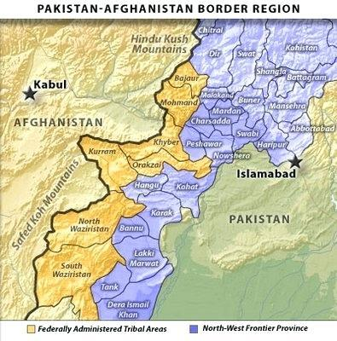
Waziristan hills:
Location:
In the south of Safed koh range, bordered by river kurram in the north and river gomal in the south.
General terrain/outcrop of the land/ appearance:
Highly mineralized area, rugged landscape, low altitude hills. The range stretches north-south direction. Average height of the range is 1500m above sea level.the highest peak of the range is called ilazai with an altitude of 2617m above sea level. This range forms a natural border between Pakistan and Afghanistan. Important passes of the range include tochi and gomal pass. Bannu at tochi pass and dera ismail khan are important towns and military centres.

Suleiman range
Location:
In the south of river gomal, lies the Suleiman range which runs in north-south direction.
General terrain/outcrop of the land/ appearance:
Rugged landscape, bare rocks with irregular slopes. This range stretches from north-south direction for about 500km. average height of the range is 1500m above sea level. The highest peak of the range is takhe-sulaiman with an altitude of 3383m above mean sea level. This range forms a natural barrier between Indus plains and Balochistan plateau. Important hills include bugti and marri which runs from southeast to northwest direction. Important passes of this range include Bolan Pass, which provides communication facilities to Quetta. Quetta is an important town and military base located in the northern end of Bolan Pass.
Kirthar hills:
Location:
In the west of lower Indus plain lies in a hilly area called kirthar hills.
General terrain/outcrop of the land/ appearance:
Low altitude hills, bare rocks with irregular slopes, backed by pub and hala range. It runs north-south direction for about 400km, separating lower Indus plain from Balochistan. Average altitude of the range is 1200m above mean sea level. The highest peak of the range is kutto ji kabar which is 2714m above mean sea level.
Drainage features:
Safed koh range:
The drainage slope of the Safed koh range is generally in eastward direction. Important rivers of Safed koh range include river Kabul and river kurram, which flow eastward and drain into river Indus. These rivers are seasonal in nature and have high flow during winter season mainly due to western depression rainfall. Warsak dam on river Kabul and kurram garhi dam on river kurram are the main sources of irrigation water to vale of Peshawar and other adjoining farming areas.
Waziristan hills:
The drainage slope of Waziristan hills include river kurram, river tochi and river gomal which flow eastward and drain into river Indus. These rivers are seasonal in nature and have high flow during winter season mainly due to western depression rainfall. Kurram garhi dam at river kurram and gomal dam on river gomal are the main sources of irrigation water to the farming valleys. Important valleys and military centres of Waziristan hills include Bannu and dera ismail khan.
Suleiman range:
The drainage slope of the Suleiman range is generally in southward direction. Important rivers of Suleiman range include Bolan River which passes through Bolan Pass and is absorbed in the kachi sibbi plain. Kandhar and kolachi rivers are two other small tributaries of river Indus and carry very limited amount of water. These rivers are extremely seasonal in nature and have high flow of water during winter season mainly due to western depression rainfall.
Kirthar range:
The drainage slope of the kirthar hills is usually in southward direction. The kirthar hills are drained by the hub and lyari streams which join Arabian Sea near Karachi. These rivers are extremely seasonal in nature and have high flow of water during summer season mainly due to summer monsoon rainfall.
Human economic activities of western mountains:
Lumbering: It refers to the extraction of wood from the forest which is an important and economic activity of the people living in the western mountains of Pakistan. Lumbering is carried out:
- To obtain fuel wood for domestic heating and cooking purpose
- To obtain commercial wood or timber for furniture industries
Crop farming: The climate and relief of western mountains donot support large scale farming. Small scale farming is carried out mostly on terraced fields while valley floors are cultivated by canal irrigation water from Warsak and kurram dams. Mostly food crops are grown including wheat, barley, millets while on some terraced farms, sugar cane is also cultivated to make gur (raw/brown sugar).
Livestock farming: Small scale livestock farming is practiced in mountainous areas in order to obtain meat, milk, wool and other byproducts. Common animals of western mountains include goat, sheep and cattle which can survive harsh climate and can easily move on mountain slopes.
Fruit farming: Another important economic activity of the people is fruit farming both on business and on commercial level. Common fruits grown in the orchids, along the road sides and on valley floors include apples, apricots, plums, peaches, almonds and walnuts. Fruits not only provide nutrition and vitamins to the local population but they are also supplied to large cities like Islamabad, Lahore, Faisalabad and Karachi.
Industries: Rugged landscape and inhospitable climatic conditions make it very difficult and costly to provide infrastructure facilities like roads, railways water supply and electricity etc. except for few urban areas like Peshawar many areas are not served with infrastructure facilities as a result industries and other business activities have not been established. Many people are engaged in cotton/craft and small industries. Important small scale and cottage industries of western mountains include furniture making, carpet weaving and embroidery etc.
Transhumance: People of western mountains usually live nomadic and semi nomadic lives called transhumance which can be classified as a type of livestock farming. Mountain people move to the plains and valleys during winter season along with their livestock and belongings and they move back to the mountains in summer season.
Potwar plateau:
Relief features:
Potwar plateau:
Location:
In the south of Himalayas, the area of Rawalpindi, Jhelum and mianwali districts are known as powar plateau. It bordered on the east by river Jhelum, on the west by river Indus, on the north by kala chitta range and on the south by salt range.
General terrain/outcrop of the land/ appearance:
Rugged and dissected landscape, extensive undulating and uneven surface covering an area of 18000 sq.km with an average altitude ranging from 300-600m above sea level. It is marked by a typical badland cut by deep ravines, locally called khaderas. Other relief features are characterized by ridges, troughs, depressions and irregular slopes. Ridges and residual hills made of limestone and sandstone are common e.g. khairi Murat, khairi mar and kala chitta.
Salt range:
The southern part of the plateau if represented by the areas of salt range with an average altitude of 600m above mean sea level. Sakesar is the highest peak which rises to 1527m above sea level. The salt range comprises parallel ranges of low, flat topped hills enclosing small intermontane valleys, basin plains and a number of saline lakes. At Kalabagh the range crosses the river Indus and then continues south west into Bannu district. Large quantities of rock salt and other minerals like gypsum and coal are found in this range.
Drainage features:
Potwar plateau and salt range:
The drainage slope of the plateau is in south-west direction. Drainage of Potwar plateau is dominated by river Indus and river Jhelum which drain the western and eastern part of the plateau respectively. Other important seasonal rivers include Soan River and Haro River, which flow mostly during summer season carrying the water of summer monsoon rainfall and finally join river Indus at kalabagh. Large saline lakes include khabeki and kallar-kahar which are highly seasonal and add to the natural beauty of the area.
Human economic activities on Potwar plateau:
Mineral extraction: Potwar plateau and salt range are rich in nonmetallic minerals such as rock salt, gypsum, limestone, soapstone, marble, clay, and fossil fuels including coal and mineral oil. As a result mining and oil drilling activities are extensively carried out in this region.
Crop farming: The relief features of Potwar plateau donot support canal irrigation. As a result, large scale commercial farming is very rare. Small scale barani farming (rain fed cultivation) is carried out mostly on terraced fields depending on western depression rainfall. Mostly food crops are grown including wheat, barley, maize and gram while on some terraced fields sugar cane is also cultivated to make Gur (raw sugar/brown sugar).
Livestock farming: Small scale livestock (pastoral) farming is practiced in these areas in order to obtain meat, milk and other byproducts. Common animals reared in this area are goat, sheep and cattle.
Industries: Potwar plateau is rich in nonmetallic minerals which provide raw materials to cement, ceramic and chemical industries. The availability of fossil fuels including mineral oil has led to the development of Pakistan’s largest oil refinery “the Attock oil refinery limited,” which has encouraged the development of many other ancillary industries in this region. Presence of mineral resources and development of secondary industries has made Potwar plateau an economically productive region where infrastructure facilities including roads, railways, airports, electricity and communication are well developed.
Balochistan plateau:
Relief features:
Location:
This plateau lies to the west of Suleiman and Kirthar Mountain in the southwest of Pakistan.
General terrain/appearance/outcrop of the land:
Rugged and dissected landscape, most difficult and complex geological structures covering an extensive area of 347000km.sq with an average altitude of 600m above sea level. The highest peak of the plateau is called Ras Koh with an altitude of 3010m above sea level.
Mountain ranges:
The relief is characterized by dry hills that run across the plateau from north east to south west. Important mountain ranges include:
- Tobakakar range and Chagai range in the north to separate it from Afghanistan
- Sehan range, central brahui ranges and makran range lie in the center
- Coastal makran range skirts south of the plateau
- Other smaller ranges include Ras koh, hala and pab range
Depressions/ low lying areas:
The plateau has a number of irregular depressions towards the north east between Suleiman range and toba kakar range such as Zhob basin and loralai basin. Small depressions in the south are locally called hamuns and salt lakes which are filled with water during rainy season and remain dry for the rest of the year. The largest one is called hamun-e-mashkel while other important ones include hamun-e-murgho and hamun-e-lora.
Plain areas:
Important plains located in Balochistan include kachi sibbi plain and lasbella plain.
Mountain passes:
Important mountain passes of Balochistan include Bolan Pass, gonshero pass and khojak pass.
Desert area:
A large area in the north west of Balochistan is covered with kharan desert which is an extremely arid area with rocky outcrop.
Coastal areas:
The coastal area of Balochistan is broadly divided in two parts; lasbella plain covering the eastern parts of the Balochistan coast and the makran coast covering the western parts of Balochistan coast.
Drainage features:
North and north eastern Balochistan:
The general slope of northern and north eastern Balochistan is in eastward direction. The drainage of northern Balochistan is dominated by Zhob river which is a seasonal river and flows in north east direction to join gomal river which then drains into river Indus. Other important seasonal of the north east Balochistan include Kandhar and kalachi rivers which flow eastward and drain into river Indus.
Inland drainage of central Balochistan:
The inland drainage of central Balochistan is described as a process in which rivers are either absorbed into land or evaporated or drained into depressions or lakes called hamuns e.g. hamun-e-mashkel. These rivers of inland drainage are unable to reach open sea and the main reasons for the development of inland drainage in Balochistan include:
- Scarcity of rainfall
- Hot climate
- Dry land/topsoil
Important rivers of inland drainage includes bolan river, Loralai River, Chakkar River and Mula River.
Southern Balochistan:
A number of small seasonal rivers flow in southern Balochistan which flow southward and eventually drain into Arabian Sea. Important rivers in southern Balochistan include Hub River, Porali River, Hingol River, Mashkai River and Dasht River which carried the water of Nihing River and Kech River.
Human economic activities of Balochistan plateau:
Mineral extraction: Balochistan plateau is rich in metallic and nonmetallic minerals including fossil fuels like coal and natural gas. Saindak mines located in the north west of Balochistan covering an extensive area of kharan district are producing gold, copper and silver while other important minerals such as gypsum, lead and chromite are extracted from Zhob, khuzdar and Muslim bagh area. Balochistan plateau is also rich in fossil fuels including coal which is extracted from Quetta coal field area where Harnai, Sor range, Mach and degari are famous mining sites.
Marine fishing: Fishing is the most dominating economic activity on Balochistan coast where both small scale subsistence and large scale commercial fishing is carried out. Important fishing centres of Balochistan coast include Gwadar, Pasni, Ormara and jiwani. Most fish catch of Balochistan is exported to Sri Lanka.
Crop farming: In general, Balochistan plateau is an arid to semi-arid area which receives a small amount of rainfall and there is scarcity of fresh water due to the shortage of water and uneven relief. This area is not suitable for cultivation. In few areas of khuzdar, Quetta and pishin, cultivation of various crops is possible with the help of Karez irrigation system.
Fruit farming: One of the most important economic and farming activities of Balochistan includes fruit farming. The main fruits grown are pomegranates, grapes, apples, plumes, apricots, peaches, almonds and dates. Most fruits produced in the areas are normally sent to large nearby markets of Karachi, Hyderabad and to different cities of Punjab.
Livestock farming: Small scale subsistence livestock farming is practiced in Balochistan where balochi people rear goats, sheep and camels to obtain milk, meat, skin and other by products. Some large scale commercial dairy farms are developed in and around Quetta city to fulfil local requirements of meat and milk as well as to export their products to Middle Eastern countries.
Industries: Although Balochistan is rich in metallic and nonmetallic minerals but due to rugged terrain and lack of infrastructure facilities most minerals are unexplored which hinders industrial development in the area. Some small scale industries including cotton textile and woolen textile are developed in and around Quetta to fulfil local demand of textile products.
Why is Balochistan undeveloped?
- No roads
Question:
“If developed, Balochistan can feed the whole pakistan.” Why or why not would you agree or disagree with the statement. (4)
- No electricity
- No communication
- Poor law and order situation
- Political instability/unrest
- Rugged terrain
- Limited capital investment
- Lack of skilled and unskilled labor force
- Shortage of fresh water
- Low priority given by government
Economic potential of Balochistan plateau:
Mineral resources: Large deposits of metallic and nonmetallic minerals are found in Balochistan which can be explored and exploited with the development of infrastructure facilities in the province such as roads, railways, electricity and communication networks, etc.
Marine fishing: The coastline of Pakistan is broadly divided into Sindh coast, comprising nearly 30% of the total coastline and Balochistan coast comprising 70% of the total coastline. The Balochistan coast is marked by a number of small fishing ports with one recently developed large port of Gwadar which can contribute a lot to the economy of Pakistan if provided with fish processing facilities and better means of transport and communication.
Agriculture: Small scale agriculture in Balochistan is mainly dependent on Karez irrigation system and thus the productivity of land is very low. By constructing small dams and reservoirs water can be stored for agricultural use while tube wells and canals can be used to provide irrigation water for large scale cash crop farming. Fruit farming can be further promoted in this area to increase exports and to fulfil local demand of fruits in large cities of Pakistan. Livestock farming can be encouraged on large scale if the local people are provided with counselling and livestock research facilities which can increase the foreign exchange earnings through exports of livestock and their byproducts.
Manufacturing and processing industry: Development of infrastructure including road and railway networks, power supply lines and communication networks can boost the mining activity in Balochistan which can attract a number of manufacturing and processing industries utilizing locally produced raw materials such as cement industry, woolen textile industry, leather industry etc.
Foreign trade: The relative location of Balochistan makes it a very important area to conduct foreign trade with neighboring countries like Iran and Afghanistan. Also, if provided with proper transport infrastructure can connect Pakistan to landlocked countries of central Asia which can use the deep sea port of Gwadar for their trade with outer world.
Indus plains
Upper Indus plain (UIP):
Relief features:
Location:
It lies in the north eastern Pakistan covering an extensive area of upper and central Punjab extending from Attock in the north to mithankot in the south.
General terrain/appearance/outcrop of the land:
Plat, flat smooth, extensive, undulating land including most parts of the Punjab province. The UIP has an altitude of 180m to 300m above sea level. Most of the area of UIP are dominated by alluvial soil brought by the river Indus and its eastern tributaries but near Sargodha, chiniot and Sangla some dry hills appear above the surface called Kirana Hills. The five big rivers of Punjab drain this plain and the land lies between two rivers called doab (interfluves) and thus there are four doabs on UIP.
Examples of doab:
Sind sagar doab: it lies between river Indus and river Jhelum covering areas of mianwali, muzzafarabad, lieah and Sargodha.
Chaj doab: it lies between river Jhelum and river Chenab covering areas of Gujrat, jhang and lieah districts
Rachna doab: it lies between river Chenab and river Ravi covering areas of sheikhupura, Gujranwala, Sialkot and Faisalabad districts
Bari doab: it lies between river Ravi and river Sutlej covering areas of Lahore, Kasur, sahiwal and Multan

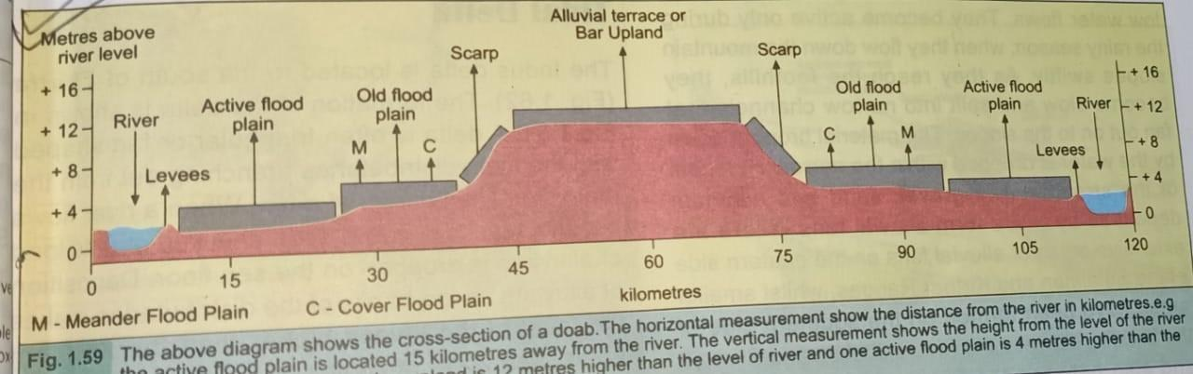
Features of a doab:

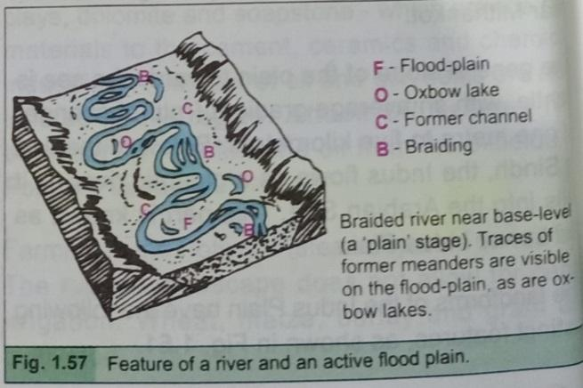
Active flood plains: narrow strips of land on either sides of a river. The land slops or dips down the river. Generally the height of the land varies from 2-3m above sea level. It is also called a bet or khaddar. This land floods annually during a summer season. It is covered by recent alluvium called khaddar soil. It is characterized by levees, meanders and oxbow lakes/dhands and dhoros.
Alluvial terrace/scalloped interfluves/ bar upland: the land in the center of the doab rises to an elevated plain is called a bar or alluvial terrace. It is covered by old alluvium deposits. General altitude varies from 10-12m above river level. It is most protected areas from flooding due to its altitude. It is mostly cultivated by means of canals and tube wells. Many parts of Bahawalpur plain have similar height as the bars of the doabs. These areas lie within the boundary of Indus plain and have been reclaimed by means of canal irrigation.
Various bars in different doabs of Punjab:
Sindh sagar doab-none-indus and Jhelum
Chaj doab: Kirana bar- Jhelum and Chenab
Rachna doab: sandal bar- Chenab and Ravi
Bari doab: ganji bar and nili bar – Ravi and Sutlej
Old flood plains: away from active flood plain areas the land rises on the old flood plain. The land slops/ dips towards the river. Width or extents of the lands varies according to the size and flow of river. Altitude of land ranges from 3-5m above river level. It is also called a bangar. It inundates every 7 to 8 years during severe flooding. It is covered by old alluvium called bangar soil. It is characterized by meander scars, abandoned channels/remains of oxbow lakes and braided channels
Levees: raised embankments on the sides of a river.
Natural levees: made of mud and soil deposited on the banks by a flowing river
Artificial/concrete levees: made of cement, concrete and rocks on the sides of the river to avoid flooding of active flood plain areas.
Bluff/cliff/escarpment: steep slope of cliff that separates old flood plain with the alluvial terrace. It is represented by old alluvium. The general altitude varies from 7-9m above river level.
Sandy plains: the land between the river Indus and river Jhelum is called Sindh sagar doab which is dominated by extensive sandy plains called thal desert. It is covered with very low and large number of sand dunes. Dust storms are very common resulting extensive soil erosion.
Piedmont plains: These plains lie between the foothills of the mountains and the old flood plain of river. These plains are dominated by the coarser materials including gravels, pebbles and sand eroded and deposited by the flowing river. Alluvial fans or cones are the dominating feature of piedmont plains. In the area of low rainfall, high temperature and scarce surface water reservoirs, the alluvial fans are considered ideal for the construction of Karez because of high groundwater table and softer material on the surface which helps construction of Karez. On UIP, piedmont plains are common in the north between foothills of Siwaliks and the old flood plains of river Jhelum while in the west of UIP these plains are found between the foothills of Waziristan and Suleiman hills and the old flood plains of river Indus.
Drainage features:
Upper Indus plain:
The general slope of UIP is in southwest direction with a gradient of 1m/5km. River Indus is the main perennial river of UIP with its width varying 1.3-1.4km. The drainage is dominated by river Indus and its eastern tributaries namely river Jhelum, river Ravi, river Chenab and river Sutlej. River Beas is a tributary of river Sutlej in India. All eastern tributaries of river Indus including Jhelum, Chenab, Ravi, Sutlej and Beas join together at punjnad to form Punjnad River which flows for 72km in southwest direction and joins river Indus at mithan kot.
Lower Indus plain (LIP):
Relief features:
Location:
It lies to the south of UIP covering an extensive area of Sindh province extending from mithankot in the north to Indus delta in the south.
General terrain/appearance and outcrop of the land:
Plain, flat, smooth, extensive, undulating land including most parts of Sindh province on either side of river Indus.
Active flood plains (same as UIP)
Old flood plains (same as UIP)
Piedmont plains: (same as UIP)
On LIP, the piedmont plains are located between the foothills of kirthar range and the old flood plain of river Indus.
Cuestas:
Cuestas are the ridges with steep slope on one side and gentle slope on the other. In Sindh or on LIP there are two cuestas namely Ganjo Takkar near Hyderabad and rohri cuesta in upper Sindh. These cuestas/ridges are made of limestone thus can be used as a source of raw material (limestone) for cement and other associated industries. They also provide firm foundations for the construction of barrages and also add to the scenic beauty of the area.
Indus delta:
Triangular piece of land where a river splits into distributaries and drain into open sea, is called delta. It is a depositional feature of an old age river thus Indus delta is dominated by deposition of alluvium. It starts from thatta district where river Indus splits into two major distributaries namely gujro and ochito which then drain Arabian Sea. Estuaries are the seasonal lakes or depressions carrying saline water and formed between the distributaries of Indus on Indus delta.
Drainage features:
LIP:
The LIP has southward slope with a gradient of 1m/10km. river Indus flows alone as a gigantic perennial river with a width of nearly 1.6km. Nara River is a small eastern tributary of Indus that flows only during summer season to drain monsoon rainfall into river indus. South of thatta, river Indus splits into distributaries to form its delta and finally drains into Arabian Sea.
Human economic activities on Indus plain:
Lumbering: UIP and LIP are covered with extensive irrigated forests including change manga, chichawatni, khanewal and Hyderabad, thus lumbering or extraction of wood for domestic and commercial purposes, is an important economic activity on Indus plain. Indus delta is covered with mangrove type of vegetation which supplies firewood and timber for local population living across the coast.
Mining: Rohri cuesta and Ganjo Takkar cuesta located on LIP serve as source of limestone quarrying for supplying raw material to local cement industries. Coal extraction from thar coal fields, located on Lower Sindh area is carried out by a large number of local people living on LIP. Natural gas extraction is carried out on upper Sindh area near the Punjab border. Important gas fields of Indus plain include Mari gas field and khairpur gas field, etc. Mineral oil extraction is an important activity on lower Sindh where laghari, mazari and Dhabi are important oil drilling sites.
Fishing: Inland fresh water fishing is practiced in rivers, lakes, canals and manmade rectangular ponds to fulfil local demand of fish and to sell it in other large cities of different provinces of Pakistan. Important inland fish species are pallah, thallah, rahu, etc.
Crop farming: Cash crop farming or large scale commercial farming is extensively practiced on UIP and LIP where geographical conditions are suitable for cultivation. Important crop producing areas of UIP are:
- Wheat in Faisalabad and jhang
- Rice in sheikhupura and Gujranwala
- Cotton in Bahawalpur and bahawalnagar
- Sugar cane in Faisalabad
Important crop producing areas in LIP are:
- Wheat in nawabshah
- Rice in larkana
- Cotton in nawabshah and sanghar
- Sugarcane in nawabshah and thatta
Fruit farming: A large area of Indus plain is reserved for fruit farming in orchids such as:
- Citrus fruits in Punjab namely khanewal
- Mangoes in Multan and rahimyarkhan
- Dates in khairpur and Jacobabad
- Bananas in ranipur and Hyderabad
Livestock farming: Natural terrain, warm to hot climate and availability of fresh water on indus plain promote livestock farming both on small scale subsistence and large scale commercial farming. Large scale commercial cattle farms are common which help producing meat and milk for every growing population of the country. Buffalo is very common and typical animal on Indus plain contributing a major share in the milk and meat production. A large number of goat farms are well distributed throughout the Indus plains because it’s easier and economically feasible to rear goats to open, flat land with plenty of water and grasses for grazing. In the village economy apart from providing draft power in agriculture, livestock also plays an important role by providing meat, milk, skin and other by product for family consumption as well as for sale purpose to earn money.
Industries: The Indus plain has a number of secondary industries distributed throughout the region of upper and lower Indus plain. Most of the industries on Indus plain are agro-based industries, utilizing locally produced raw materials such as cotton textile, sugar mills, wheat flour mills, etc. important cottage craft industries of Indus plain include bangle making, jewelry making and embroidery. Important small scale industries include sports good industries, surgical instrument industries, cutlery industry, etc. important large scale industries of indus plain include cotton textile industry, sugar mills, fertilizers, cement industry, leather industry, tannery, etc. Most industrial products are supplied to a large local market while others are exported to other countries to earn foreign exchange.
Tourism: A number of natural, cultural and historical attractions have been made available for tourism on Indus plain. Important natural attractions on Indus plain include wildlife like blind Indus dolphin, national parks like kirthar national park and bird sanctuaries like wetland centres and fresh water lakes in Sindh. A number of cultural attractions which have been developed on indus plain as tourist destination include archeological sites such as Mehr Garh (prehistoric), Mohenjo-Daro and Harappa (indus valley civilization), taxila and takht-i-bhal i.e. Gandharan Buddhist civilization. Several important historical sites of indus plain include Lahore fort, badshahi mosque, shah jehan mosque, Shalimar gardens, allama Iqbal’s and ranjit Singh’s tombs in Lahore, sultan-sar-mast’s tomb near sukkur, clock towers in Faisalabad and Hyderabad, etc. Other important tourist destinations of Indus plain include minar-e-pakistan, chashma and sukkur barrages, traditional crafts and bazaar such as anarkali bazaar and Food Street in Lahore.
Trade: Indus plain being the most important industrialized physical region of Pakistan, contribute a major share in domestic and international markets.
Transport and communication: Infrastructure facilities including roads, railways, airways, water supply and electricity are much easier to develop on Indus plain which encourage industrialization and high population density in the region.
Vale of Peshawar:
Relief and drainage features:
The vale of Peshawar is located in the western highlands of Pakistan. It is surrounded by mountains from three sides i.e. Hindu Kush to the north, Safed koh to the west and Waziristan hills to the south. This plain valley consists of Peshawar and mardan districts and it has been formed by the alluvial sediments brought by swat and Kabul Rivers. A large number of crops are cultivated with help of irrigation canals taken from Warsak dam on river Kabul.
Deserts of Pakistan:
Kharan desert:
Relief features:
Location:
It lies to the south-western part of Pakistan covering an extensive area of kharan district in north western Balochistan.
General terrain/relief features: Kharan is a rocky desert, located in the north western Balochistan. The outcrop is dominated by bare rocks, lose soil with very little or no vegetation. It covers an extensive area dominated by strong winds and weathering of rocks. It experiences extremely arid conditions with less than 125mm/year of rainfall. Inhospitable climatic conditions with summer temperatures over 40 degree centigrade and cool to cold winter make this area devoid of natural vegetation.
Economic activities: Mining of metallic minerals including copper, gold and silver is an important economic activity in kharan district. Saindak copper and gold mines are producing metallic minerals mainly for export and some nonmetallic minerals use within the country.

Thal desert:
Relief features:
Location:
Thal desert is located on Sind sagar doab in between river Indus and river Jhelum.
General terrain/relief features:
Thal is a sandy desert dominated by extensive sandy plains with arid climatic conditions i.e. mean annual rainfall remains under 250mm per year. Many parts of the desert are being converted to farmland by means of irrigation through canals and tube wells. Farming is the dominating occupation in the region, where depending on the availability of irrigation water people grow a variety of crops including wheat.
South eastern desert:
Relief features:
Location:
It is located to the south east of Pakistan. It is further divided into three deserts namely choilstan desert in the south eastern Punjab, Nara desert in the north eastern Sindh and tharparkar desert in south eastern Sindh.
General terrain:
Extensive strips, sandy plains called Pattis. Latitudinal and longitudinal rolling sand dunes. Bare rocks with marks of weathering and wind erosion. Lose soil with very little moisture in it very sparse thorny and cactus type vegetation. Broad inter-dunal valleys covered by lose sand
Human economic activities in south eastern desert: Parts of south eastern desert have been reclaimed with the help of irrigation canals taken from river indus. People also store water in ditches and ponds to cultivate land. Common crops grown in the region include vegetables, chilies, and spices and in canal irrigated areas cotton is also grown.

